Lab 3 Work
UML Diagram Generation with AI
Course: Automation of Scientific Research
Name: Bilal Zai Mohammad Wasim
Date: 06/01/2026

Aim:
Using a library management system as the case study, compare the quality of UML diagrams produced by various AI models and prompt levels. to assess the accuracy of the PlantUML code and the degree to which the diagrams satisfy the specifications.

Models Used
• AI models: ChatGPT (GPT-5.2), DeepSeek (3.2)
System under study
Library management system
Actors (example): Reader, Library, Admin.

4. Use Case Diagram – Results

4.1 Prompt
Prompt Text:
[Generate PlantUML code for a library management system use case diagram. Identify the actors and list the main use cases.]

Model | Plant UML code (@startuml…@enduml) | Render (OK/Error)
ChatGPT (GPT-5.2), | @startuml  title Library Management System — Use Case Diagram  left to right direction  skinparam packageStyle rectangle  ' Actors  actor "Library Member" as Member  actor "Librarian" as Librarian  actor "Administrator" as Admin  actor "Guest" as Guest  rectangle "Library Management System" {  ' Guest / Public  usecase "Search Catalog" as UC_Search  usecase "View Book Details" as UC_ViewDetails  usecase "Register Account" as UC_Register  ' Member  usecase "Log In" as UC_Login  usecase "Update Profile" as UC_Profile  usecase "Borrow Item" as UC_Borrow  usecase "Return Item" as UC_Return  usecase "Renew Loan" as UC_Renew  usecase "Place Hold / Reserve" as UC_Reserve  usecase "Cancel Hold" as UC_CancelHold  usecase "View Loans & History" as UC_History  usecase "Pay Fine" as UC_PayFine  ' Librarian  usecase "Issue Loan (Checkout)" as UC_Checkout  usecase "Accept Return (Check-in)" as UC_Checkin  usecase "Register Member" as UC_RegMember  usecase "Manage Holds" as UC_ManageHolds  usecase "Collect Fine" as UC_CollectFine  usecase "Add / Update / Remove Item" as UC_ManageItems  usecase "Manage Inventory" as UC_Inventory  usecase "Generate Reports" as UC_Reports  ' Admin  usecase "Manage Users & Roles" as UC_Roles  usecase "Configure Policies\n(loan periods, fines)" as UC_Policies  usecase "Manage System Settings" as UC_Settings  usecase "Audit Logs" as UC_Audit  }  ' Associations  Guest --> UC_Search  Guest --> UC_ViewDetails  Guest --> UC_Register  Member --> UC_Login  Member --> UC_Search  Member --> UC_ViewDetails  Member --> UC_Profile  Member --> UC_Borrow  Member --> UC_Return  Member --> UC_Renew  Member --> UC_Reserve  Member --> UC_CancelHold  Member --> UC_History  Member --> UC_PayFine  Librarian --> UC_Checkout  Librarian --> UC_Checkin  Librarian --> UC_RegMember  Librarian --> UC_ManageHolds  Librarian --> UC_CollectFine  Librarian --> UC_ManageItems  Librarian --> UC_Inventory  Librarian --> UC_Reports  Admin --> UC_Roles  Admin --> UC_Policies  Admin --> UC_Settings  Admin --> UC_Audit  ' Includes / Extends (typical relationships)  UC_Borrow .> UC_Checkout : <<include>>  UC_Return .> UC_Checkin : <<include>>  UC_PayFine .> UC_CollectFine : <<include>>  UC_Renew .> UC_History : <<extend>>  UC_Reserve .> UC_Search : <<extend>>  UC_CancelHold .> UC_Reserve : <<extend>>  @enduml | OK
DeepSeek (3.2) | @startuml  left to right direction  skinparam actorStyle awesome  ' Определение действующих лиц (акторов)  actor Библиотекарь as librarian  actor Читатель as reader  actor Администратор as admin  actor "Каталогизатор" as cataloger  actor "Внешняя платежная система" as payment  ' Определение границ системы  rectangle "Система управления библиотекой" {  ' Основные варианты использования, сгруппированные по акторам  (Поиск книг и информации) as UC1  (Регистрация нового читателя) as UC2  (Выдача книги) as UC3  (Прием возвращенной книги) as UC4  (Продление срока возврата) as UC5  (Формирование отчетов) as UC6  (Управление книжным фондом) as UC7  (Бронирование книги) as UC8  (Оплата штрафов) as UC9  (Управление учетными записями) as UC10  (Ведение электронного каталога) as UC11  (Работа с поставщиками) as UC12  }  ' Связи акторов с вариантами использования  ' Читатель  reader --> UC1  reader --> UC5  reader --> UC8  reader --> UC9  ' Библиотекарь (основной пользователь)  librarian --> UC1  librarian --> UC2  librarian --> UC3  librarian --> UC4  librarian --> UC5  librarian --> UC9  librarian --> UC6  librarian --> UC7  librarian --> UC8  librarian --> UC11  ' Каталогизатор  cataloger --> UC7  cataloger --> UC11  ' Администратор  admin --> UC6  admin --> UC10  admin --> UC12  ' Внешняя система  payment --> UC9  ' Связи между вариантами использования (include/extend)  ' Базовые сценарии  UC3 .> UC1 : include  UC8 .> UC1 : include  ' Расширения (дополнительное поведение)  UC9 .> UC4 : extend  UC5 .> UC3 : extend  ' Примечание  note right of UC9  Взаимодействие с внешней  платежной системой  end note  @enduml | OK
DeepSeek
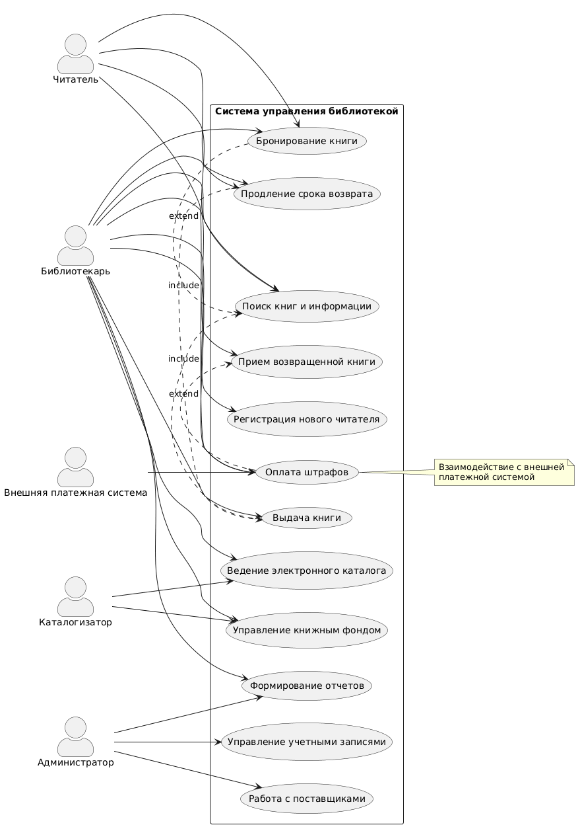
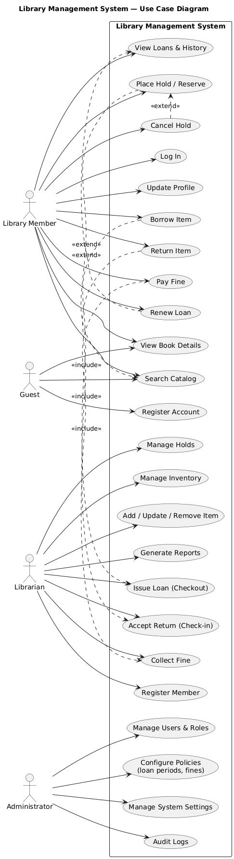

The diagrams were correctly drawn, and both ChatGPT and DeepSeek generated valid PlantUML code (OK). Roles and use cases, including include/extend relations, are clearly separated in ChatGPT's more thorough diagram. Although DeepSeek's output is more condensed and simulates an external payment system, its applications are broader. For a comprehensive LMS use-case view, ChatGPT is superior overall.

4.2 Prompt
Prompt Text:
Сгенерируй PlantUML код для диаграммы вариантов использования системы управления библиотекой. Используй акторов: Читатель (Reader), Библиотекарь (Librarian), Администратор (Admin). Для каждого актора укажи 5–8 основных вариантов использования (use cases). Сделай границу системы (system boundary) “Library Management System”. Дай полный код от @startuml до @enduml

Model | Plant UML code (@startuml…@enduml) | Render (OK/Error)
ChatGPT (5.2) | @startuml  title Library Management System - Use Case Diagram  left to right direction  skinparam packageStyle rectangle  actor "Читатель (Reader)" as Reader  actor "Библиотекарь (Librarian)" as Librarian  actor "Администратор (Admin)" as Admin  rectangle "Library Management System" {  ' Reader use cases (5–8)  usecase "Search Catalog" as UC_Search  usecase "View Item Details" as UC_ViewDetails  usecase "Borrow Item" as UC_Borrow  usecase "Return Item" as UC_Return  usecase "Renew Loan" as UC_Renew  usecase "Place Hold / Reserve" as UC_Reserve  usecase "View Loans & History" as UC_History  usecase "Pay Fine" as UC_PayFine  ' Librarian use cases (5–8)  usecase "Register Reader" as UC_RegReader  usecase "Issue Loan (Checkout)" as UC_Checkout  usecase "Accept Return (Check-in)" as UC_Checkin  usecase "Manage Holds" as UC_ManageHolds  usecase "Collect Fine" as UC_CollectFine  usecase "Add / Update / Remove Item" as UC_ManageItems  usecase "Inventory Control" as UC_Inventory  usecase "Generate Operational Reports" as UC_OpReports  ' Admin use cases (5–8)  usecase "Manage Users & Roles" as UC_UsersRoles  usecase "Configure Loan Policies" as UC_Policies  usecase "Configure Fine Rules" as UC_Fines  usecase "Manage System Settings" as UC_Settings  usecase "Audit Logs" as UC_Audit  usecase "Backup / Restore Data" as UC_Backup  usecase "Manage Integrations" as UC_Integrations  usecase "Generate Administrative Reports" as UC_AdminReports  }  ' Associations  Reader --> UC_Search  Reader --> UC_ViewDetails  Reader --> UC_Borrow  Reader --> UC_Return  Reader --> UC_Renew  Reader --> UC_Reserve  Reader --> UC_History  Reader --> UC_PayFine  Librarian --> UC_RegReader  Librarian --> UC_Checkout  Librarian --> UC_Checkin  Librarian --> UC_ManageHolds  Librarian --> UC_CollectFine  Librarian --> UC_ManageItems  Librarian --> UC_Inventory  Librarian --> UC_OpReports  Admin --> UC_UsersRoles  Admin --> UC_Policies  Admin --> UC_Fines  Admin --> UC_Settings  Admin --> UC_Audit  Admin --> UC_Backup  Admin --> UC_Integrations  Admin --> UC_AdminReports  ' Typical include relationships  UC_Borrow .> UC_Checkout : <<include>>  UC_Return .> UC_Checkin : <<include>>  UC_PayFine .> UC_CollectFine : <<include>>  @enduml | OK
DeepSeek(3.2 ) | @startuml  left to right direction  skinparam packageStyle rectangle  title Library Management System - Use Case Diagram  ' Define system boundary  rectangle "Library Management System" {  ' Define use cases for all actors within system boundary  (Search Catalog) as UC1  (Borrow Book) as UC2  (Return Book) as UC3  (Renew Loan) as UC4  (View Loan History) as UC5  (Place Hold) as UC6  (Pay Fine) as UC7  (Update Profile) as UC8  (Process Checkout) as UC9  (Process Return) as UC10  (Manage Holds) as UC11  (Manage Fines) as UC12  (Add New Book) as UC13  (Update Book Status) as UC14  (Generate Reports) as UC15  (Register New Member) as UC16  (Manage User Accounts) as UC17  (Manage Staff Accounts) as UC18  (Configure System Settings) as UC19  (Backup System Data) as UC20  (View System Logs) as UC21  (Manage Library Inventory) as UC22  (Set Loan Policies) as UC23  (Manage Library Branches) as UC24  }  ' Define actors  actor "Reader" as reader  actor "Librarian" as librarian  actor "Admin" as admin  ' Reader connections  reader --> UC1 : <<extend>>\nSearch by title/author  reader --> UC2 : <<include>>\nRequires valid membership  reader --> UC3  reader --> UC4 : <<extend>>\nIf no holds  reader --> UC5  reader --> UC6 : <<extend>>\nWhen book unavailable  reader --> UC7 : <<extend>>\nFor overdue items  reader --> UC8  ' Librarian connections  librarian --> UC9 : <<include>>\nRequires UC1  librarian --> UC10  librarian --> UC11  librarian --> UC12  librarian --> UC13  librarian --> UC14 : <<extend>>\nMark as lost/damaged  librarian --> UC15  librarian --> UC16  ' Admin connections  admin --> UC17  admin --> UC18  admin --> UC19  admin --> UC20  admin --> UC21  admin --> UC22  admin --> UC23  admin --> UC24  ' Define relationships between use cases  UC2 .> UC1 : <<include>>  UC9 .> UC1 : <<include>>  UC7 .> UC10 : <<extend>>  UC6 .> UC1 : <<include>>  ' Group use cases visually  together {  UC1; UC2; UC3; UC4; UC5; UC6; UC7; UC8  }  together {  UC9; UC10; UC11; UC12; UC13; UC14; UC15; UC16  }  together {  UC17; UC18; UC19; UC20; UC21; UC22; UC23; UC24  }  ' Add notes for clarification  note top of UC2  Reader can borrow up to  10 items for 21 days  end note  note right of UC12  Librarian can waive or  adjust fines with reason  end note  note left of UC19  Admin can configure  loan periods, fine rates,  and system parameters  end note  @enduml | error

ChatGPT
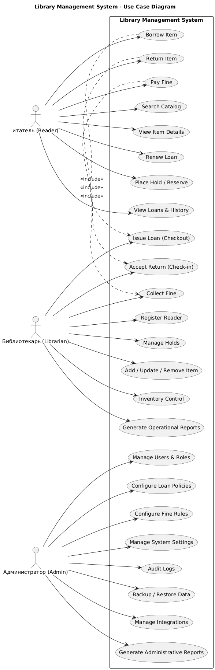
DeepSeek
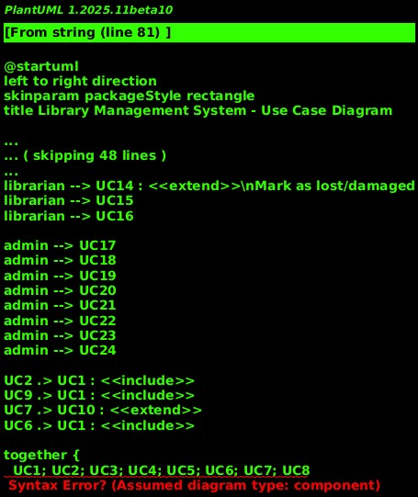

The use case diagram was successfully drawn (OK), and ChatGPT generated valid PlantUML code. A syntax error produced by jointly {... } prevented DeepSeek's initial output from rendering, and PlantUML assumed a different diagram type. The diagram can be produced once that portion has been deleted or rewritten. On the first try, ChatGPT was generally more dependable.

4.3 prompt:
Prompt text:
Create a journal-quality use case diagram (PlantUML) for a library management system. Include the following actors: Reader, Librarian, and Administrator. Use cases should cover: catalog searching, lending/returning/renewing books, reservations, fines payments, inventory management, user/role management, and reporting. Add appropriate <> and <> relationships where logical. Display the complete PlantUML code from @startuml to @enduml. No bulleted lists, no additional explanations—just the code
Model | Plant UML code (@startuml…@enduml) | Render (OK/Error)
ChatGPT(5.2) | @startuml  title Library Management System - Use Case Diagram  left to right direction  skinparam packageStyle rectangle  skinparam shadowing false  actor "Reader" as Reader  actor "Librarian" as Librarian  actor "Administrator" as Administrator  rectangle "Library Management System" as LMS {  usecase "Search Catalog" as UC_Search  usecase "View Book Details" as UC_ViewDetails  usecase "Borrow Book" as UC_Borrow  usecase "Return Book" as UC_Return  usecase "Renew Loan" as UC_Renew  usecase "Reserve Book" as UC_Reserve  usecase "Pay Fine" as UC_PayFine  usecase "Calculate Fine" as UC_CalcFine  usecase "Record Payment" as UC_RecordPayment  usecase "Manage Inventory" as UC_ManageInventory  usecase "Add/Update/Remove Book" as UC_BookCRUD  usecase "Update Book Status\n(available/loaned/lost)" as UC_BookStatus  usecase "Manage Users & Roles" as UC_UserRoles  usecase "Manage Reader Accounts" as UC_ReaderAccounts  usecase "Authenticate User" as UC_Auth  usecase "Reporting" as UC_Reporting  usecase "Operational Reports" as UC_OpReports  usecase "Administrative Reports" as UC_AdminReports  }  Reader --> UC_Search  Reader --> UC_ViewDetails  Reader --> UC_Borrow  Reader --> UC_Return  Reader --> UC_Renew  Reader --> UC_Reserve  Reader --> UC_PayFine  Librarian --> UC_ManageInventory  Librarian --> UC_ReaderAccounts  Librarian --> UC_Reporting  Librarian --> UC_RecordPayment  Administrator --> UC_UserRoles  Administrator --> UC_Reporting  Administrator --> UC_AdminReports  UC_Search ..> UC_ViewDetails : <<include>>  UC_Borrow ..> UC_Auth : <<include>>  UC_Return ..> UC_Auth : <<include>>  UC_Renew ..> UC_Auth : <<include>>  UC_Reserve ..> UC_Auth : <<include>>  UC_PayFine ..> UC_CalcFine : <<include>>  UC_PayFine ..> UC_RecordPayment : <<include>>  UC_ManageInventory ..> UC_BookCRUD : <<include>>  UC_ManageInventory ..> UC_BookStatus : <<include>>  UC_ReaderAccounts ..> UC_Auth : <<include>>  UC_UserRoles ..> UC_Auth : <<include>>  UC_Reporting ..> UC_OpReports : <<include>>  UC_Renew ..> UC_Borrow : <<extend>>  UC_Reserve ..> UC_Search : <<extend>>  UC_AdminReports ..> UC_Reporting : <<extend>>  @enduml | OK
DeepSeek 3.2 | @startuml  skinparam {  BackgroundColor #F8F9FA  ArrowColor #2C3E50  ActorBorderColor #2C3E50  UseCaseBorderColor #34495E  UseCaseBackgroundColor #ECF0F1  UseCaseFontColor #2C3E50  ActorFontColor #2C3E50  ActorBackgroundColor #E8F4FD  }  title Library Management System - Use Case Diagram  left to right direction  actor "Reader" <<Member>> as Reader  actor "Librarian" <<Staff>> as Librarian  actor "Administrator" <<Staff>> as Administrator  rectangle "Library Management System" {  ' Reader use cases  (Search Catalog) as UC1  (View Item Details) as UC2  (Borrow Book) as UC3  (Return Book) as UC4  (Renew Loan) as UC5  (Place Reservation) as UC6  (Cancel Reservation) as UC7  (View Loan History) as UC8  (Pay Fine Online) as UC9  (Update Personal Information) as UC10  ' Librarian use cases  (Process Check-out) as UC11  (Process Return) as UC12  (Process Renewal) as UC13  (Manage Reservations) as UC14  (Calculate & Apply Fines) as UC15  (Accept Fine Payment) as UC16  (Add New Inventory Item) as UC17  (Update Item Status) as UC18  (Remove Damaged/Lost Items) as UC19  (Generate Circulation Reports) as UC20  ' Administrator use cases  (Manage User Accounts) as UC21  (Assign User Roles) as UC22  (Define Fine Policies) as UC23  (Set Loan Periods) as UC24  (Configure System Parameters) as UC25  (Backup/Restore System Data) as UC26  (Generate Financial Reports) as UC27  (Generate Inventory Reports) as UC28  (Manage Library Branches) as UC29  }  ' Reader connections  Reader --> UC1  Reader --> UC2  Reader --> UC3  Reader --> UC4  Reader --> UC5  Reader --> UC6  Reader --> UC7  Reader --> UC8  Reader --> UC9  Reader --> UC10  ' Librarian connections  Librarian --> UC11  Librarian --> UC12  Librarian --> UC13  Librarian --> UC14  Librarian --> UC15  Librarian --> UC16  Librarian --> UC17  Librarian --> UC18  Librarian --> UC19  Librarian --> UC20  ' Administrator connections  Administrator --> UC21  Administrator --> UC22  Administrator --> UC23  Administrator --> UC24  Administrator --> UC25  Administrator --> UC26  Administrator --> UC27  Administrator --> UC28  Administrator --> UC29  ' Include relationships  UC3 .> UC1 : <<include>>  UC11 .> UC1 : <<include>>  UC11 .> UC3 : <<extend>>  UC12 .> UC4 : <<extend>>  UC13 .> UC5 : <<extend>>  UC15 .> UC12 : <<include>>  UC9 .> UC15 : <<extend>>  UC16 .> UC9 : <<extend>>  UC18 .> UC17 : <<extend>>  UC6 .> UC1 : <<include>>  UC7 .> UC6 : <<extend>>  UC14 .> UC6 : <<include>>  UC14 .> UC7 : <<extend>>  ' Extend relationships  UC5 .> UC3 : <<extend>>  UC6 .> UC3 : <<extend>> \nwhen unavailable  UC15 .> UC4 : <<extend>> \non overdue items  UC18 .> UC19 : <<include>>  UC21 .> UC22 : <<include>>  UC24 .> UC23 : <<include>>  UC28 .> UC17 : <<include>>  UC28 .> UC18 : <<include>>  UC28 .> UC19 : <<include>>  note right of UC1  Search by:  - Title  - Author  - ISBN  - Subject  - Keyword  end note  note bottom of UC3  Maximum 10 items  Loan period: 21 days  end note  note left of UC15  Fine calculation based on:  - Overdue days  - Item type  - User category  end note  note top of UC21  Includes:  - Create account  - Deactivate account  - Update privileges  - Reset password  end note  @enduml | OK

ChatGPT
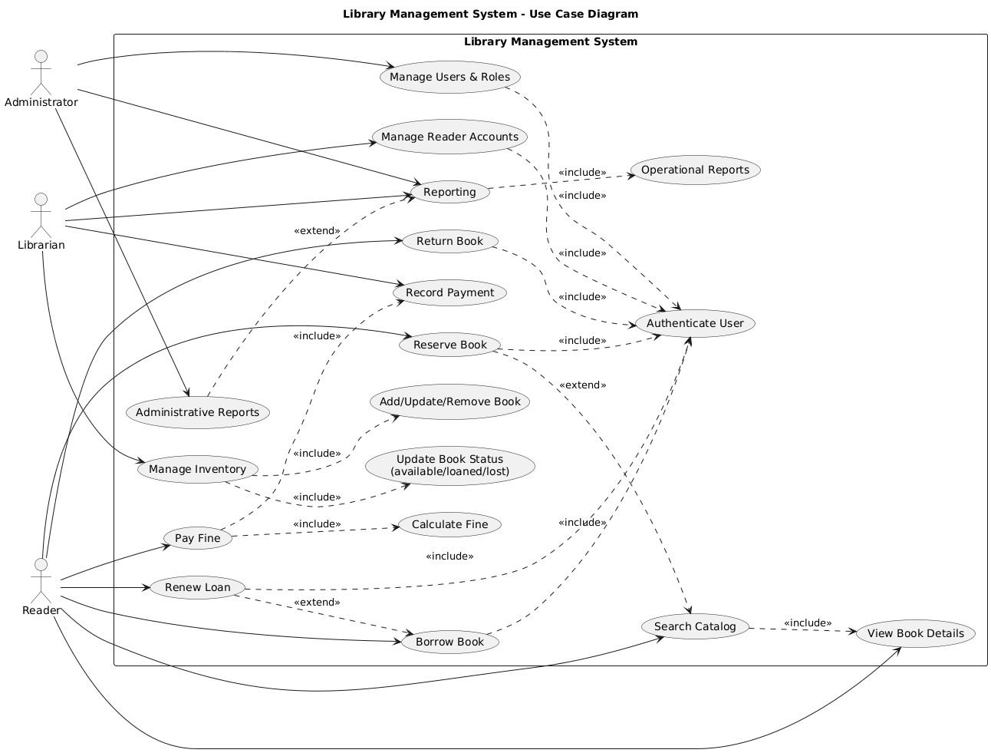

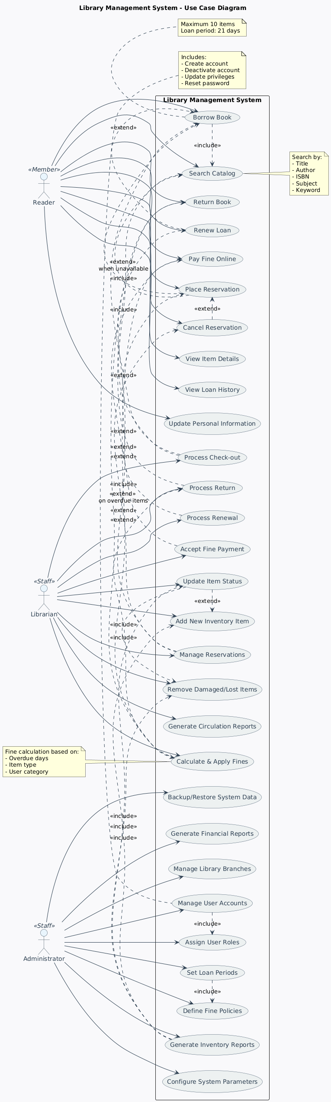
DeepSeek

Both products are successfully presented (good), but ChatGPT provides a cleaner and more logically consistent use case model with clearer naming and more appropriate <<include>>/<<extend>> relationships (e.g., the shared "verify user"). DeepSec is more detailed and visually styled, but many of the relationships are questionable (e.g., "loan book includes search catalog" and mixed include/extend instructions), which may reduce the correctness of the UML. ChatGPT also maps well to the essential functions (search/loan/return/renewal/reserve/fines/inventory/user role/reporting) without unnecessary complexity. Overall, ChatGPT is a better choice for Prompt 3 due to its high clarity and UML consistency.
4.4 Prompt:
Prompt text:
Create a journal quality use case diagram (PlantUML) for a library management system.
Actors: Reader, Librarian, Administrator.
Requirements:
Use cases should include: Search catalog, View item details, Borrow, Return, Renew, Cancel reservation, Pay fine.
Library should include: Check out/check in, Manage reservations, Manage inventory (add/update/remove), Generate reports.
Administrator should include: User and role management, Policy configuration (loan period/fine), Audit/Logs, Reporting.
Add realistic <<Include>> and <<Extend>> relationships (e.g., verification, fine calculation, early check-in).
Use system boundaries and keep the diagram readable (avoid excessive duplication).
Export only the complete PlantUML code from @startuml to @enduml.
Model | Plant UML code (@startuml…@enduml) | Render (OK/Error)
ChatGPT(5.2) | @startuml  title Library Management System - Use Case Diagram  left to right direction  skinparam packageStyle rectangle  skinparam shadowing false  skinparam usecase {  BackgroundColor White  BorderColor Black  ArrowColor Black  }  actor "Reader" as Reader  actor "Librarian" as Librarian  actor "Administrator" as Admin  rectangle "Library Management System" as LMS {  ' Core catalog  usecase "Search Catalog" as UC_Search  usecase "View Item Details" as UC_ViewDetails  ' Reader circulation  usecase "Borrow Item" as UC_Borrow  usecase "Return Item" as UC_Return  usecase "Renew Loan" as UC_Renew  usecase "Cancel Reservation" as UC_CancelRes  usecase "Pay Fine" as UC_PayFine  ' Library operations  usecase "Check Out (Issue Loan)" as UC_CheckOut  usecase "Check In (Accept Return)" as UC_CheckIn  usecase "Manage Reservations" as UC_ManageRes  usecase "Manage Inventory" as UC_Inventory  usecase "Add/Update/Remove Item" as UC_ItemCRUD  usecase "Generate Reports" as UC_Reports  ' Administration  usecase "User & Role Management" as UC_UserRoles  usecase "Policy Configuration\n(loan period, fines)" as UC_Policy  usecase "Audit / Logs" as UC_Audit  usecase "Administrative Reporting" as UC_AdminReports  ' Shared/Supporting  usecase "Verify Member Eligibility" as UC_Verify  usecase "Validate Item Availability" as UC_Availability  usecase "Calculate Fine" as UC_CalcFine  usecase "Record Payment" as UC_RecordPay  usecase "Update Item Status" as UC_UpdateStatus  usecase "Notify Reader" as UC_Notify  usecase "Early Check-in" as UC_EarlyCheckin  }  ' Associations  Reader --> UC_Search  Reader --> UC_ViewDetails  Reader --> UC_Borrow  Reader --> UC_Return  Reader --> UC_Renew  Reader --> UC_CancelRes  Reader --> UC_PayFine  Librarian --> UC_CheckOut  Librarian --> UC_CheckIn  Librarian --> UC_ManageRes  Librarian --> UC_Inventory  Librarian --> UC_Reports  Admin --> UC_UserRoles  Admin --> UC_Policy  Admin --> UC_Audit  Admin --> UC_AdminReports  ' <<include>> (mandatory sub-functions)  UC_Search ..> UC_ViewDetails : <<include>>  UC_Borrow ..> UC_Verify : <<include>>  UC_Borrow ..> UC_Availability : <<include>>  UC_Borrow ..> UC_CheckOut : <<include>>  UC_Return ..> UC_CheckIn : <<include>>  UC_Return ..> UC_CalcFine : <<include>>  UC_PayFine ..> UC_CalcFine : <<include>>  UC_PayFine ..> UC_RecordPay : <<include>>  UC_CheckOut ..> UC_UpdateStatus : <<include>>  UC_CheckIn ..> UC_UpdateStatus : <<include>>  UC_Inventory ..> UC_ItemCRUD : <<include>>  UC_ManageRes ..> UC_Notify : <<include>>  UC_AdminReports ..> UC_Reports : <<include>>  ' <<extend>> (optional/conditional behavior)  UC_Renew ..> UC_Borrow : <<extend>>  UC_CancelRes ..> UC_ManageRes : <<extend>>  UC_EarlyCheckin ..> UC_CheckIn : <<extend>>  @enduml | OK
DeepSeek 3.2 | @startuml  skinparam {  backgroundColor #FFFFFF  arrowColor #2C3E50  actorBorderColor #2C3E50  useCaseBorderColor #34495E  useCaseBackgroundColor #F8F9FA  useCaseFontColor #2C3E50  actorFontColor #2C3E50  actorBackgroundColor #EDF2F7  }  title Library Management System - Use Case Diagram  left to right direction  actor "Reader" <<Member>> as Reader  actor "Librarian" <<Staff>> as Librarian  actor "Administrator" <<Admin>> as Admin  package "Library Core System" {  rectangle "Public Interface" {  (Search Catalog) as UC1  (View Item Details) as UC2  (View Account Status) as UC3  (Update Personal Info) as UC4  (Borrow Item) as UC5  (Return Item) as UC6  (Renew Loan) as UC7  (Place Reservation) as UC8  (Cancel Reservation) as UC9  (Pay Fine) as UC10  }  rectangle "Staff Operations" {  (Verify Membership) as UC11  (Process Check-out) as UC12  (Process Check-in) as UC13  (Calculate Fine) as UC14  (Accept Payment) as UC15  (Waive Fine) as UC16  (Manage Inventory) as UC17  (Add New Item) as UC18  (Update Item Status) as UC19  (Remove Item) as UC20  (Generate Reports) as UC21  (Circulation Report) as UC22  (Inventory Report) as UC23  }  rectangle "Administration" {  (Manage User Accounts) as UC24  (Create User) as UC25  (Update Privileges) as UC26  (Deactivate Account) as UC27  (Configure Policies) as UC28  (Set Loan Periods) as UC29  (Define Fine Rates) as UC30  (Manage Holidays) as UC31  (View Audit Logs) as UC32  (Backup System) as UC33  (System Health Report) as UC34  }  }  ' Reader connections  Reader --> UC1  Reader --> UC2  Reader --> UC3  Reader --> UC4  Reader --> UC5  Reader --> UC6  Reader --> UC7  Reader --> UC8  Reader --> UC9  Reader --> UC10  ' Librarian connections  Librarian --> UC11  Librarian --> UC12  Librarian --> UC13  Librarian --> UC14  Librarian --> UC15  Librarian --> UC16  Librarian --> UC17  Librarian --> UC18  Librarian --> UC19  Librarian --> UC20  Librarian --> UC21  Librarian --> UC22  Librarian --> UC23  ' Administrator connections  Admin --> UC24  Admin --> UC25  Admin --> UC26  Admin --> UC27  Admin --> UC28  Admin --> UC29  Admin --> UC30  Admin --> UC31  Admin --> UC32  Admin --> UC33  Admin --> UC34  ' Include relationships  UC1 .> UC2 : <<include>>  UC5 .> UC11 : <<include>>  UC12 .> UC11 : <<include>>  UC12 .> UC5 : <<include>>  UC13 .> UC6 : <<include>>  UC14 .> UC13 : <<include>> \nwhen overdue  UC15 .> UC10 : <<include>>  UC17 .> UC18 : <<include>>  UC17 .> UC19 : <<include>>  UC17 .> UC20 : <<include>>  UC21 .> UC22 : <<include>>  UC21 .> UC23 : <<include>>  UC24 .> UC25 : <<include>>  UC24 .> UC26 : <<include>>  UC24 .> UC27 : <<include>>  UC28 .> UC29 : <<include>>  UC28 .> UC30 : <<include>>  UC28 .> UC31 : <<include>>  ' Extend relationships  UC7 .> UC5 : <<extend>> \nbefore due date  UC8 .> UC5 : <<extend>> \nwhen unavailable  UC9 .> UC8 : <<extend>>  UC10 .> UC14 : <<extend>>  UC16 .> UC15 : <<extend>> \nwith justification  UC19 .> UC13 : <<extend>> \nearly check-in  UC19 .> UC20 : <<extend>> \nif lost/damaged  UC26 .> UC12 : <<extend>> \noverride limits  UC30 .> UC14 : <<extend>>  ' Cross-package relationships  UC22 .> UC12 : <<include>>  UC22 .> UC13 : <<include>>  UC23 .> UC17 : <<include>>  UC32 .> UC12 : <<include>>  UC32 .> UC24 : <<include>>  UC34 .> UC21 : <<include>>  note top of UC5  Preconditions:  - Active membership  - No overdue items  - Under loan limit  end note  note right of UC14  Fine calculation considers:  - Overdue days  - Item type (book/CD)  - User category  - Holiday schedule  end note  note bottom of UC28  Policy settings affect:  - Loan periods  - Renewal limits  - Reservation holds  - Fine accumulation  end note  @enduml | OK
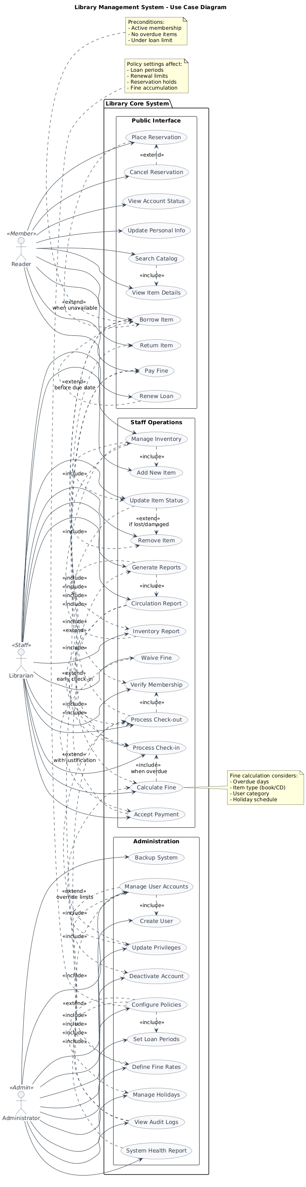
ChatGPT
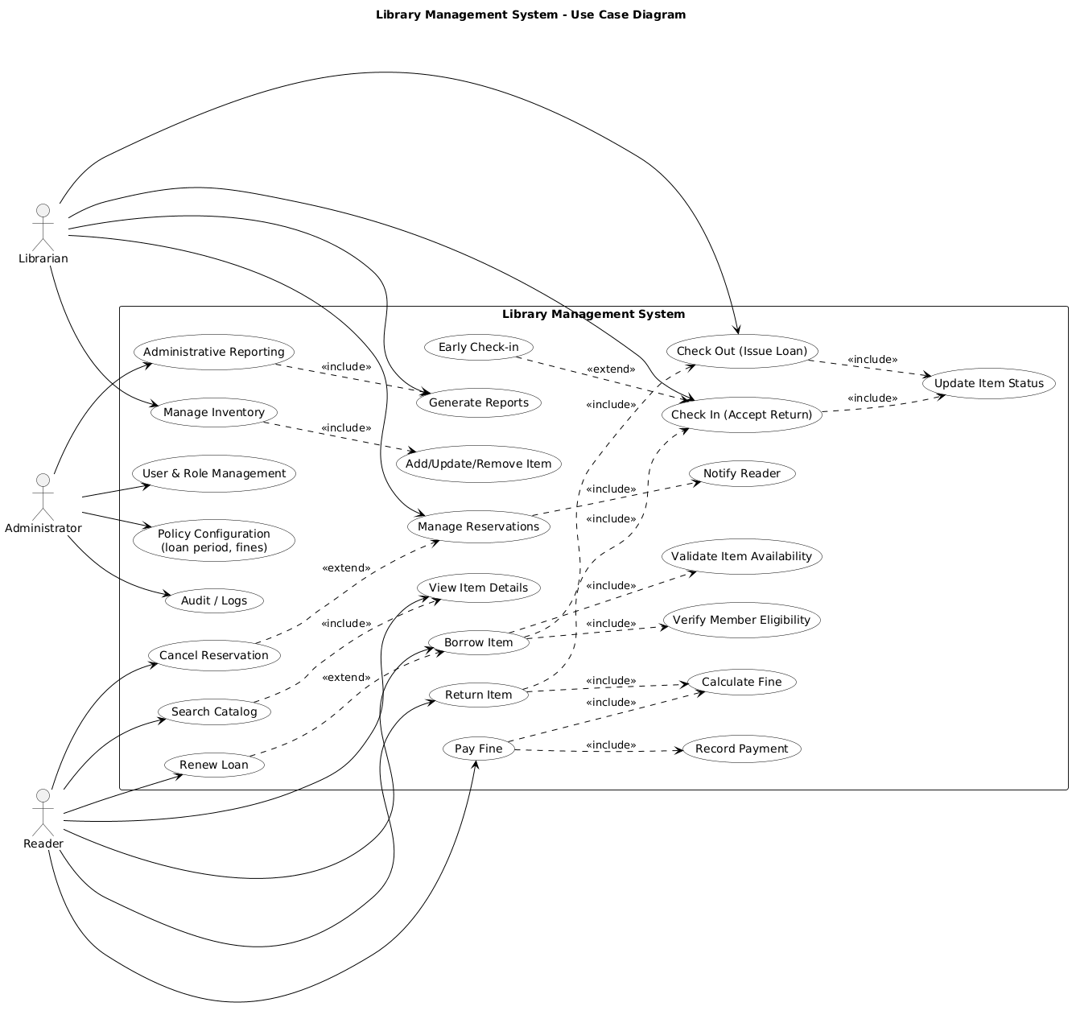

Both ChatGPT and DeepSeek are well presented (well) and cover the essential actors and core functions. ChatGPT is cleaner and more readable, with well-chosen supporting use cases (capacity, availability, good accounting/payment) and constant <<include>>/<<extend>> links. DeepSeek is more comprehensive and well-structured into subsystems, but it is more complex and includes additional use cases that may be beyond the scope of the minimum. Overall, ChatGPT is better for short "journal quality" diagrams, while DeepSeek is useful when maximum detail is needed.
5. Class Diagram — Results
5.1 Prompt
Generate PlantUML code for a class diagram of a library management system.
Include key classes (at least 8-12), such as: library, catalog, book/item, user, reader, librarian, manager, loan, reservation, and fine/payment.
Show relationships between classes (unions and inheritance where appropriate).
Keep it simple (no features yet).
Send the complete PlantUML code only from @startuml to @enduml.
Model | Plant UML code (@startuml…@enduml) | Render (OK/Error)
ChatGPT(5.2) | @startuml  title Library Management System - Class Diagram  skinparam classAttributeIconSize 0  skinparam shadowing false  class Library  class Catalog  class Item  class Book  class User  class Reader  class Librarian  class Manager  class Loan  class Reservation  class Fine  class Payment  ' Inheritance  User <|-- Reader  User <|-- Librarian  User <|-- Manager  Item <|-- Book  ' Core ownership / containment  Library "1" o-- "1" Catalog  Library "1" o-- "0..*" Item  Library "1" o-- "0..*" User  ' Catalog relationships  Catalog "1" --> "0..*" Item : indexes  ' Circulation  Reader "1" --> "0..*" Loan : borrows  Loan "1" --> "1" Item : item  Loan "1" --> "1" Reader : borrower  Reader "1" --> "0..*" Reservation : places  Reservation "1" --> "1" Item : item  Reservation "1" --> "1" Reader : requester  ' Fines and payments  Loan "0..1" --> "0..1" Fine : may generate  Fine "1" --> "1" Reader : charged to  Fine "1" --> "0..*" Payment : settled by  Payment "1" --> "1" Reader : paid by  ' Staff responsibilities  Librarian "1" --> "0..*" Loan : processes  Librarian "1" --> "0..*" Reservation : manages  Manager "1" --> "0..*" User : manages  Manager "1" --> "1" Library : administers  @enduml | OK
DeepSeek(3.2) | @startuml  skinparam {  classBackgroundColor #F8F9FA  classBorderColor #2C3E50  classFontColor #2C3E50  arrowColor #2C3E50  }  title Library Management System - Class Diagram  class Library {  - name: String  - address: String  - phone: String  + addBook(book: Book): void  + removeBook(isbn: String): void  + registerUser(user: User): void  + searchCatalog(criteria: String): List<Book>  }  class Catalog {  - books: List<Book>  + searchByTitle(title: String): List<Book>  + searchByAuthor(author: String): List<Book>  + searchByISBN(isbn: String): Book  + addBook(book: Book): void  + removeBook(book: Book): void  }  class Book {  - isbn: String  - title: String  - author: String  - publicationYear: int  - publisher: String  - category: String  - status: BookStatus  + getStatus(): BookStatus  + updateStatus(status: BookStatus): void  }  enum BookStatus {  AVAILABLE  CHECKED_OUT  RESERVED  DAMAGED  LOST  }  class Item {  - itemId: String  - acquisitionDate: Date  - location: String  + isAvailable(): boolean  }  class User {  - userId: String  - name: String  - email: String  - phone: String  - registrationDate: Date  + getName(): String  + getEmail(): String  + updateProfile(): void  }  class Reader {  - readerId: String  - membershipExpiry: Date  - maxBooksAllowed: int  + borrowBook(book: Book): Loan  + returnBook(loan: Loan): void  + renewLoan(loan: Loan): boolean  }  class Librarian {  - employeeId: String  - hireDate: Date  + processCheckout(reader: Reader, book: Book): Loan  + processReturn(loan: Loan): void  + addBookToCatalog(book: Book): void  + generateReport(): Report  }  class Manager {  - department: String  + manageInventory(): void  + generateFinancialReport(): FinancialReport  + manageStaff(): void  }  class Loan {  - loanId: String  - borrowDate: Date  - dueDate: Date  - returnDate: Date  - status: LoanStatus  + calculateFine(): double  + isOverdue(): boolean  + renew(): boolean  }  class Reservation {  - reservationId: String  - reservationDate: Date  - expiryDate: Date  - status: ReservationStatus  + cancel(): void  + notifyAvailability(): void  }  class Fine {  - fineId: String  - amount: double  - issuedDate: Date  - dueDate: Date  - status: FineStatus  + calculateTotal(): double  + processPayment(amount: double): void  + waive(): void  }  class Payment {  - paymentId: String  - paymentDate: Date  - amount: double  - method: PaymentMethod  + process(): boolean  + generateReceipt(): Receipt  }  ' Inheritance relationships  User <|-- Reader  User <|-- Librarian  User <|-- Manager  Librarian <|-- Manager  ' Composition/Aggregation relationships  Library "1" *-- "1" Catalog  Catalog "1" *-- "0..*" Book  Book "1" -- "1..*" Item  ' Associations  Reader "1" -- "0..*" Loan  Book "1" -- "0..*" Loan  Librarian "1" -- "0..*" Loan  Loan "0..1" -- "0..1" Fine  Reader "1" -- "0..*" Reservation  Book "1" -- "0..*" Reservation  Fine "1" -- "0..*" Payment  Reader "1" -- "0..*" Fine  @enduml | OK

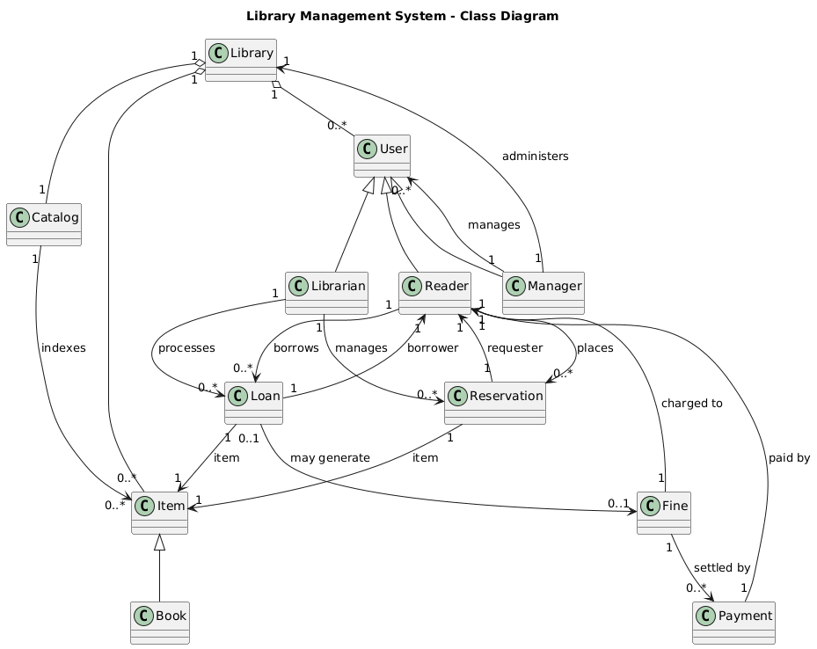
ChatGPT

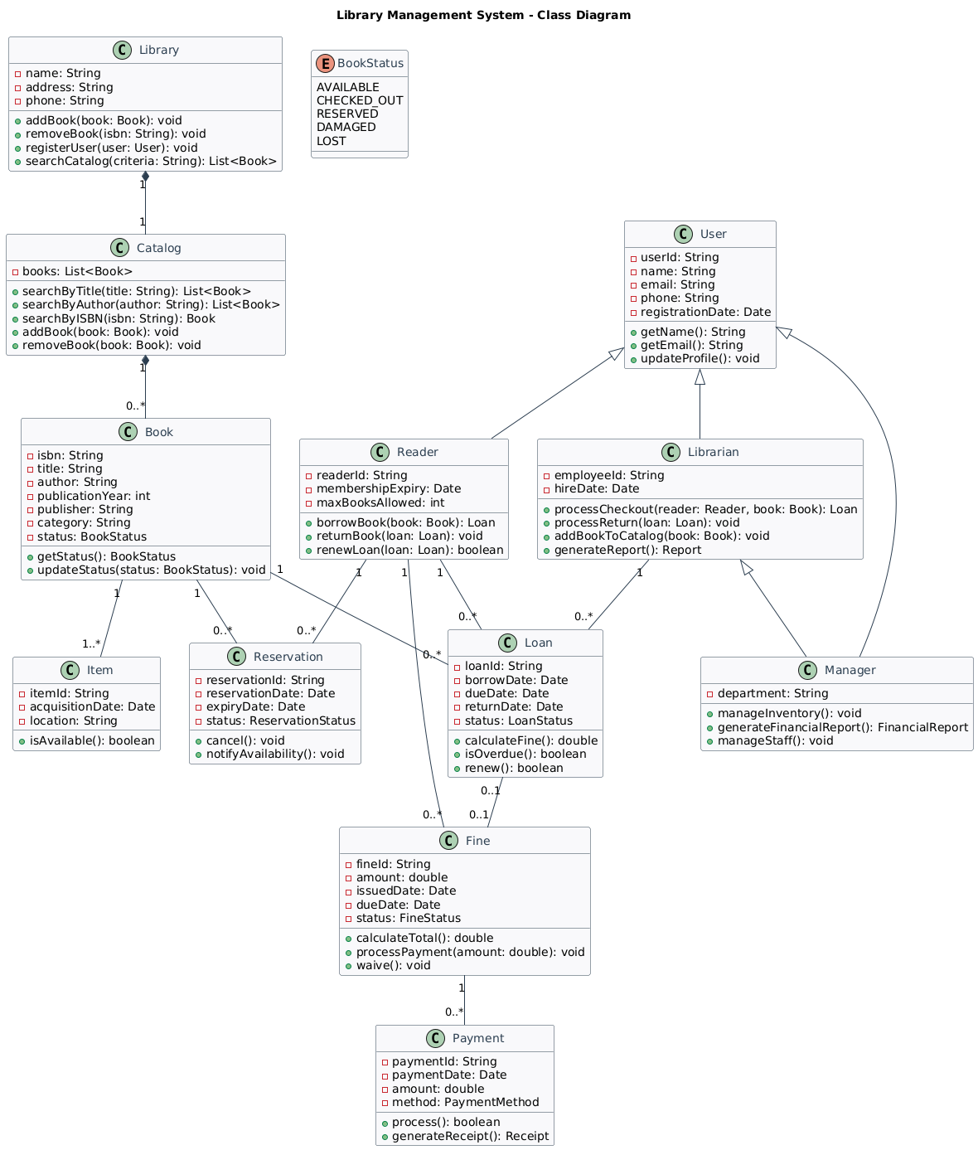
DeepSeek

Both diagrams are successfully rendered (good), but they differ in how well they meet the "simple/no attributes" requirement of Prompt 1. ChatGPT follows the prompt more closely by showing only key classes, inheritance, and parent relationships without attributes or methods. DeepSeq provides a more realistic and rich library model (for example, book-item separation and state concepts), but it goes beyond Prompt 1 by adding attributes, methods, and animations. Therefore, ChatGPT is the best choice for Prompt 1 compliance, while DeepSeek is better for a more detailed, implementation-based model.
5.2 Prompt:
Generate PlantUML code for a class diagram of a library management system.
Include key classes (library, catalog, item/book, user, reader, librarian, manager, loan, reservation, fine, payment).
Add 3-6 essential attributes to the main classes (e.g., ID, title, status, dates, size).
Keep relationships and inheritance clear, with multiplication where appropriate.
Export only the complete PlantUML code from @startuml to @enduml.
Model | Plant UML code (@startuml…@enduml) | Render (OK/Error)
ChatGPT(5.2) | @startuml  title Library Management System - Class Diagram  skinparam classAttributeIconSize 0  skinparam shadowing false  ' =========================  ' Core domain classes  ' =========================  class Library {  +libraryId: String  +name: String  +address: String  +phone: String  }  class Catalog {  +catalogId: String  +name: String  +lastUpdated: Date  }  class Item {  +itemId: String  +barcode: String  +title: String  +status: String  +location: String  }  class Book {  +isbn: String  +author: String  +publisher: String  +publishedYear: Integer  }  class User {  +userId: String  +fullName: String  +email: String  +phone: String  +status: String  }  class Reader {  +membershipId: String  +joinedDate: Date  +maxLoans: Integer  +currentLoans: Integer  }  class Librarian {  +employeeId: String  +shift: String  +workEmail: String  }  class Manager {  +employeeId: String  +department: String  +workEmail: String  }  class Loan {  +loanId: String  +issueDate: Date  +dueDate: Date  +returnDate: Date  +status: String  }  class Reservation {  +reservationId: String  +requestDate: Date  +expiryDate: Date  +status: String  }  class Fine {  +fineId: String  +amount: Decimal  +reason: String  +createdDate: Date  +status: String  }  class Payment {  +paymentId: String  +amount: Decimal  +paymentDate: Date  +method: String  +referenceNo: String  }  ' =========================  ' Inheritance  ' =========================  User <|-- Reader  User <|-- Librarian  User <|-- Manager  Item <|-- Book  ' =========================  ' Aggregation / Composition  ' =========================  Library "1" o-- "1" Catalog : has  Library "1" o-- "0..*" Item : holds  Library "1" o-- "0..*" User : registers  Catalog "1" --> "0..*" Item : indexes  ' =========================  ' Circulation relationships  ' =========================  Reader "1" --> "0..*" Loan : borrows  Loan "1" --> "1" Item : item  Loan "1" --> "1" Reader : borrower  Reader "1" --> "0..*" Reservation : places  Reservation "1" --> "1" Item : item  Reservation "1" --> "1" Reader : requester  Loan "0..1" --> "0..1" Fine : may generate  Fine "1" --> "1" Reader : charged to  Fine "1" --> "0..*" Payment : settled by  Payment "1" --> "1" Reader : paid by  ' =========================  ' Staff responsibilities  ' =========================  Librarian "1" --> "0..*" Loan : processes  Librarian "1" --> "0..*" Reservation : manages  Manager "1" --> "0..*" User : manages  Manager "1" --> "1" Library : administers  @enduml | OK
DeepSeek(3.2) | @startuml  skinparam {  classBackgroundColor #F8F9FA  classBorderColor #2C3E50  classFontColor #2C3E50  arrowColor #2C3E50  }  title Library Management System - Class Diagram  class Library {  - libraryId: String  - name: String  - address: String  - phone: String  - email: String  + addItem(item: Item): void  + registerUser(user: User): void  }  class Catalog {  - catalogId: String  - lastUpdated: Date  - totalItems: int  + searchByTitle(title: String): List<Item>  + searchByAuthor(author: String): List<Item>  + searchByISBN(isbn: String): Item  }  class Item {  - itemId: String  - isbn: String  - title: String  - author: String  - publicationYear: int  - status: ItemStatus  + isAvailable(): boolean  + updateStatus(status: ItemStatus): void  }  class Book {  - publisher: String  - edition: String  - pages: int  - category: String  }  class Magazine {  - issueNumber: int  - publicationDate: Date  - frequency: String  }  class DVD {  - director: String  - duration: int  - rating: String  }  class User {  - userId: String  - name: String  - email: String  - phone: String  - registrationDate: Date  - status: UserStatus  + updateProfile(): void  + getBorrowedItems(): List<Loan>  }  class Reader {  - membershipNumber: String  - membershipExpiry: Date  - maxLoans: int  - totalFines: double  + borrowItem(item: Item): Loan  + returnItem(loan: Loan): void  }  class Librarian {  - employeeId: String  - hireDate: Date  - department: String  - accessLevel: int  + processCheckout(reader: Reader, item: Item): Loan  + processReturn(loan: Loan): void}  class Manager {  - managerId: String  - responsibilities: String[]  + generateFinancialReport(): Report  + manageStaff(): void  }  class Loan {  - loanId: String  - borrowDate: Date  - dueDate: Date  - returnDate: Date  - status: LoanStatus  + calculateFine(): double  + isOverdue(): boolean  }  class Reservation {  - reservationId: String  - reservationDate: Date  - expiryDate: Date  - priority: int  - status: ReservationStatus  + cancel(): void  + notifyUser(): void  }  class Fine {  - fineId: String  - amount: double  - issuedDate: Date  - dueDate: Date  - status: FineStatus  + calculateTotal(): double  + processPayment(): boolean  }  class Payment {  - paymentId: String  - paymentDate: Date  - amount: double  - method: PaymentMethod  - transactionId: String  + process(): boolean  }  ' Enum definitions  enum ItemStatus {  AVAILABLE  CHECKED_OUT  RESERVED  DAMAGED  LOST  }  enum UserStatus {  ACTIVE  INACTIVE  SUSPENDED  BLACKLISTED  }  enum LoanStatus {  ACTIVE  RETURNED  OVERDUE  LOST  }  enum ReservationStatus {  PENDING  CONFIRMED  CANCELLED  EXPIRED  }  enum FineStatus {  PENDING  PAID  WAIVED  OVERDUE  }  enum PaymentMethod {  CASH  CREDIT_CARD  DEBIT_CARD  ONLINE}  ' Inheritance relationships  User <|-- Reader  User <|-- Librarian  User <|-- Manager  Item <|-- Book  Item <|-- Magazine  Item <|-- DVD  ' Composition relationships  Library "1" *-- "1" Catalog : contains >  Catalog "1" *-- "0..*" Item : manages >  ' Associations with multiplicities  Library "1" -- "0..*" User : serves >  Reader "1" -- "0..*" Loan : has >  Item "1" -- "0..*" Loan : borrowed through >  Loan "0..1" -- "0..1" Fine : generates >  Fine "1" -- "0..*" Payment : settled by >  Reader "1" -- "0..*" Reservation : places >  Item "1" -- "0..*" Reservation : reserved through >  Librarian "1" -- "0..*" Loan : processes >  Manager "1" -- "0..*" Librarian : supervises >  @enduml | OK
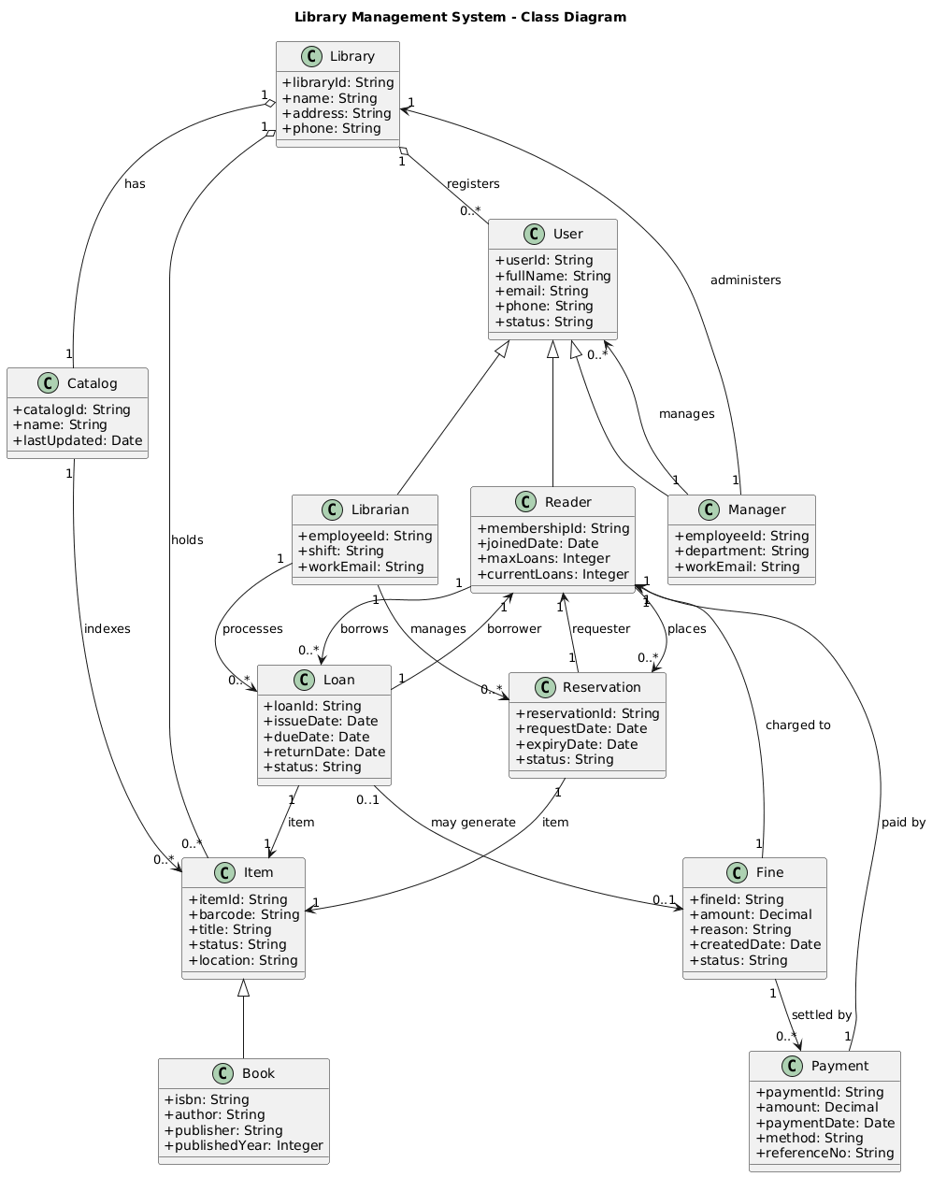
ChatGPT

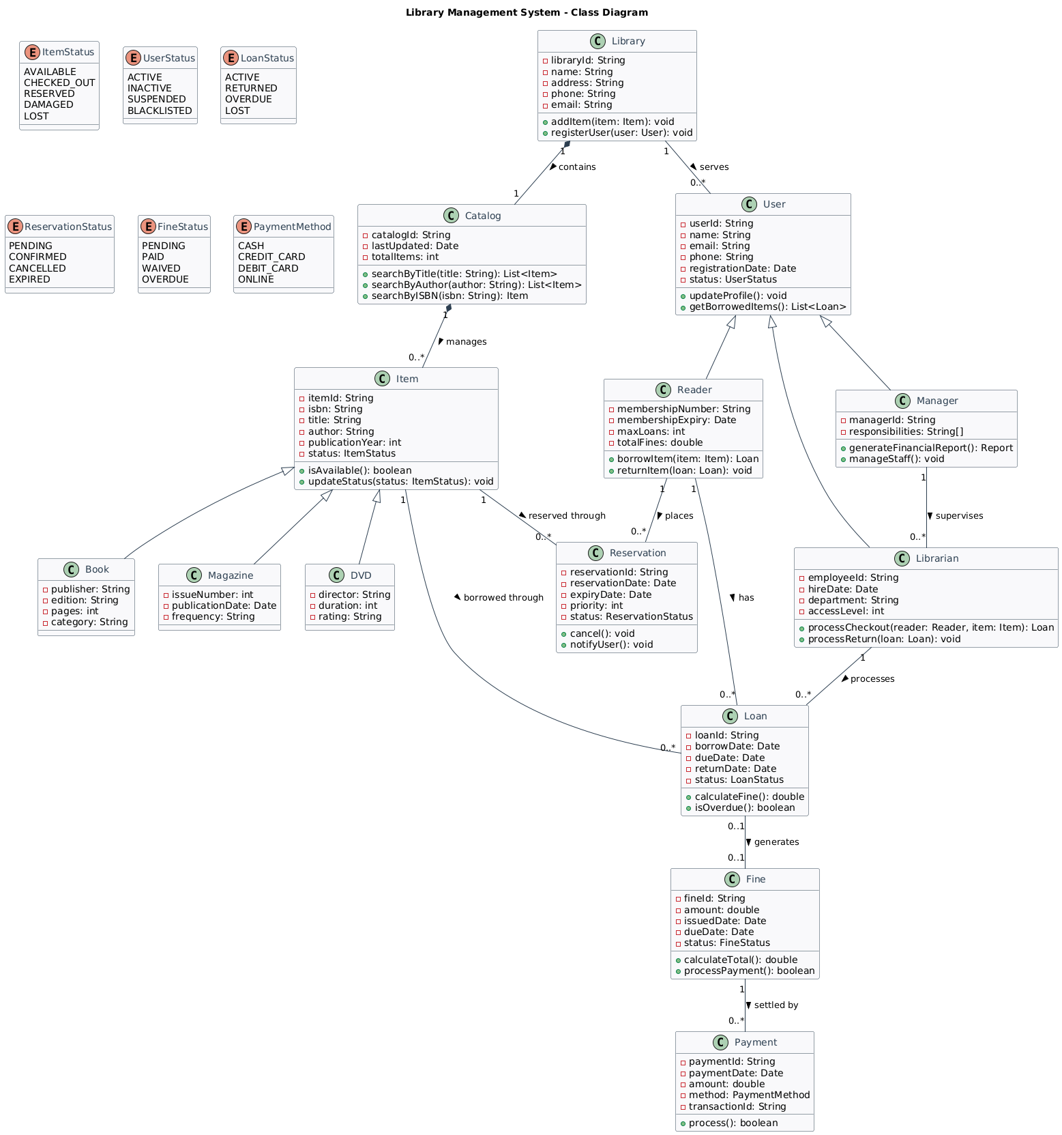
DeepSeek

The ChatGPT diagram is simple and well-suited to the stated requirements, focusing on core classes, clear inheritance, and essential relationships without unnecessary complexity.
The DeepSeek diagram is more detailed and feature-rich, but includes methods, animations, and additional classes that go beyond the basic class diagram.
In terms of readability and journal-style presentation, the ChatGPT version is clear and easy to interpret.
Overall, the ChatGPT model is more suitable for high-level academic or introductory system design.
5.3 Prompt:
Generate PlantUML code for a UML class diagram of a library management system.
Requirements:
Use inheritance: User as the base class, with Reader, Librarian, and Administrator as subclasses.
Model Book (library record) and Item (physical copy) appropriately, with clear relationships.
Use and label relationship types: Relationship, Collection, and Composition where appropriate.
Add multiples (e.g., 1, 0.., 1...).
Include at least one enum (e.g., ItemStatus or Loan Status).
Keep it readable and consistent with the library domain logic.
Only pass PlantUML code from @startuml to @enduml.
Model | Plant UML code (@startuml…@enduml) | Render (OK/Error)
ChatGPT(5.2) | @startuml  title Library Management System - UML Class Diagram  skinparam classAttributeIconSize 0  skinparam shadowing false  left to right direction  ' =========================  ' Enums  ' =========================  enum ItemStatus {  AVAILABLE  ON_LOAN  RESERVED  LOST  DAMAGED  }  enum LoanStatus {  ACTIVE  RETURNED  OVERDUE  }  ' =========================  ' Users (Inheritance)  ' =========================  abstract class User {  +userId: String  +fullName: String  +email: String  +phone: String  +status: String  }  class Reader {  +membershipId: String  +joinedDate: Date  +maxLoans: Integer  }  class Librarian {  +employeeId: String  +workEmail: String  +shift: String  }  class Administrator {  +employeeId: String  +workEmail: String  +roleLevel: Integer  }  User <|-- Reader  User <|-- Librarian  User <|-- Administrator  ' =========================  ' Bibliographic vs Physical  ' =========================  class Book {  +isbn: String  +title: String  +author: String  +publisher: String  +publishedYear: Integer  }  class Item {  +itemId: String  +barcode: String  +status: ItemStatus  +location: String  +acquiredDate: Date  }  ' =========================  ' Circulation  ' =========================  class Loan {  +loanId: String  +issueDate: Date  +dueDate: Date  +returnDate: Date  +status: LoanStatus  }  class Reservation {  +reservationId: String  +requestDate: Date  +expiryDate: Date  +status: String  }  class Fine {  +fineId: String  +amount: Decimal  +createdDate: Date  +status: String  }  class Payment {  +paymentId: String  +amount: Decimal  +paymentDate: Date  +method: String  +referenceNo: String  }  class Library {  +libraryId: String  +name: String  +address: String  }  class Catalog {  +catalogId: String  +name: String  +lastUpdated: Date  }  ' =========================  ' Labeled relationship types:  ' Relationship, Collection, Composition  ' =========================  ' Composition (strong ownership)  Library "1" *-- "1" Catalog : Composition  Library "1" *-- "0..*" Item : Composition  ' Collection (managed grouping, weaker than composition)  Catalog "1" o-- "0..*" Book : Collection  Book "1" o-- "0..*" Item : Collection (copies)  ' Relationship (associations)  Library "1" -- "0..*" User : Relationship (registered)  Reader "1" -- "0..*" Loan : Relationship (borrows)  Loan "1" -- "1" Item : Relationship (item)  Reader "1" -- "0..*" Reservation : Relationship (places)  Reservation "1" -- "1" Book : Relationship (for title)  Loan "0..1" -- "0..1" Fine : Relationship (may generate)  Fine "1" -- "0..*" Payment : Relationship (settled by)  Payment "1" -- "1" Reader : Relationship (paid by)  Librarian "1" -- "0..*" Loan : Relationship (processes)  Administrator "1" -- "1" Library : Relationship (administers)  @enduml | OK
DeepSeek(3.2) | @startuml  skinparam {  classBackgroundColor #F8F9FA  classBorderColor #2C3E50  classFontColor #2C3E50  arrowColor #2C3E50  stereotypeFontColor #E74C3C  }  title Library Management System - Class Diagram  ' Enums  enum ItemStatus {  AVAILABLE  CHECKED_OUT  RESERVED  DAMAGED  LOST  UNDER_REPAIR  }  enum LoanStatus {  ACTIVE  RETURNED  OVERDUE  LOST  }  enum UserType {  STUDENT  FACULTY  STAFF  GUEST  }  ' Base classes  class User {  - userId: String  - name: String  - email: String  - phone: String  - registrationDate: Date  - userType: UserType  - isActive: boolean  + authenticate(): boolean  + updateProfile(): void  }  class Book {  - isbn: String  - title: String  - author: String  - publisher: String  - publicationYear: int  - edition: String  - subject: String  + searchSimilar(): List<Book>  + getAvailableCopies(): List<Item>  }  class Item {  - itemId: String  - barcode: String  - acquisitionDate: Date  - location: String  - status: ItemStatus  - condition: String  + checkAvailability(): boolean  + updateStatus(status: ItemStatus): void  }  ' Subclasses  class Reader {  - readerId: String  - membershipExpiry: Date  - maxLoansAllowed: int  - currentLoansCount: int  + borrowItem(item: Item): Loan  + returnItem(loan: Loan): void  + renewLoan(loan: Loan): boolean  + getBorrowingHistory(): List<Loan>  }  class Librarian {  - employeeId: String  - hireDate: Date  - department: String  + processCheckout(reader: Reader, item: Item): Loan  + processReturn(loan: Loan): void  + addItemToCatalog(book: Book, item: Item): void  + generateCirculationReport(): Report  }  class Administrator {  - adminId: String  - accessLevel: int  + manageUserAccounts(): void  + configureSystemSettings(): void  + generateFinancialReports(): Report  + backupDatabase(): void  }  ' Related classes  class Loan {  - loanId: String  - checkoutDate: Date  - dueDate: Date  - returnDate: Date  - status: LoanStatus  + calculateFine(): double  + isOverdue(): boolean  + renew(): boolean  }  class Reservation {  - reservationId: String  - reservationDate: Date  - expiryDate: Date  - priority: int  + cancel(): void  + notifyAvailable(): boolean  }  class Fine {  - fineId: String  - amount: double  - issuedDate: Date  - dueDate: Date  - reason: String  + calculateTotal(): double  + processPayment(amount: double): boolean  }  class Catalog {  - catalogId: String  - lastUpdated: Date  + searchByTitle(title: String): List<Book>  + searchByAuthor(author: String): List<Book>  + searchBySubject(subject: String): List<Book>  }  ' Inheritance relationships  User <|-- Reader  User <|-- Librarian  User <|-- Administrator  ' Composition relationships  Book "1" *-- "1..*" Item : has copies >  Catalog "1" *-- "0..*" Book : contains >  ' Association relationships  Reader "1" -- "0..*" Loan : "borrows" >  Item "1" -- "0..*" Loan : "loaned through" >  Librarian "1" -- "0..*" Loan : "processes" >  Loan "0..1" -- "0..1" Fine : "may incur" >  Reader "1" -- "0..*" Reservation : "places" >  Book "1" -- "0..*" Reservation : "reserved for" >  Item "0..1" -- "0..1" Reservation : "fulfilled by" >  Administrator "1" -- "0..*" Librarian : "manages" >  ' Aggregation relationship  Catalog "1" o-- "0..*" Item : "tracks" >  ' Multiplicities  Reader "1" --> "0..5" Loan : "active loans"  Item "1" --> "0..1" Reader : "checked out to"  Book "1" --> "1..*" Item : "physical copies"  note "Item represents a physical copy\nof a Book (library record)" as N1  N1 .. Book  N1 .. Item  note "Fine is generated when\nLoan becomes overdue" as N2  N2 .. Loan  N2 .. Fine  @enduml | OK

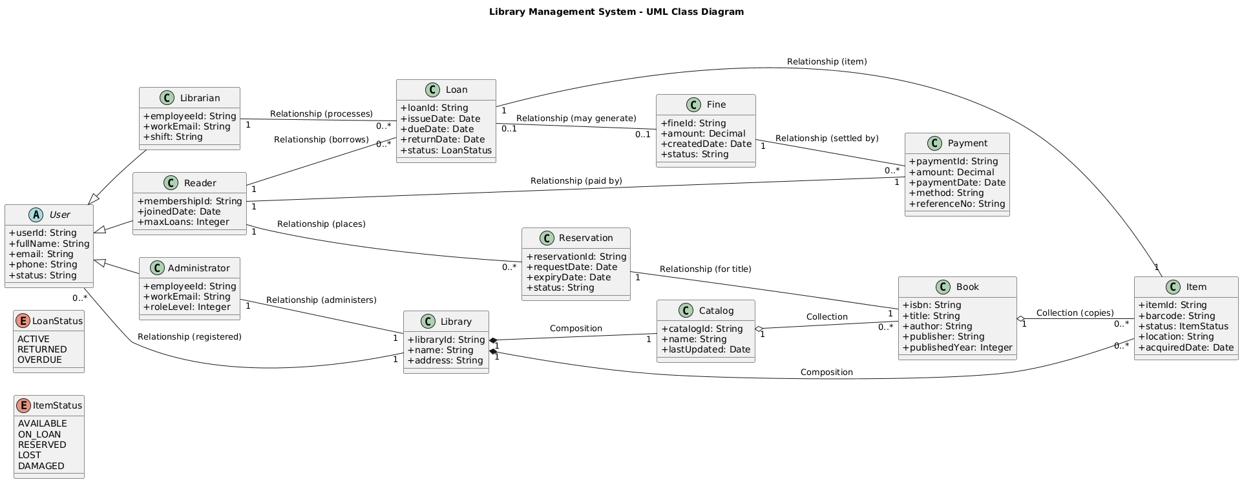
ChatGPT

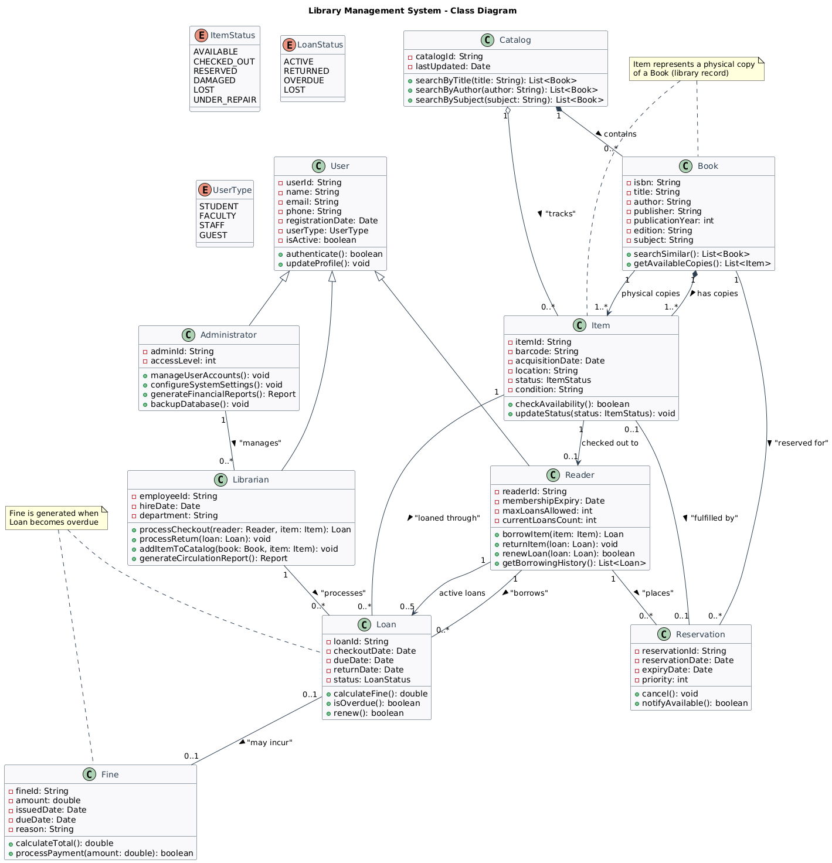
DeepSeek

Both diagrams meet the requirements of Prompt 3 (inheritance from user, book-item modeling, anime, and multiplication) and render successfully (good). ChatGPT is cleaner and more "report friendly", but it uses relationship labels like "composition/collection" as text rather than really distinguishing semantics beyond standard UML arrows. DeepSeek implements relationship types consistently (composition book-item, collection/union) and adds useful domain constraints (e.g., active loan constraints), which make the model more realistic. Overall, DeepSeek is stronger for Prompt 3 due to its clear UML semantics and rich, consistent relationships.
5.4 Prompt:
Produce a journal-quality UML class diagram (PlantUML) for a library management system.
Requirements:
Inheritance: User as base class; Reader, Librarian, Manager as subclasses.
Separate book (book record) and item (physical copy), with proper relationships.
Include classes: Library, Catalog, Loan, Reservation, Fine, and Payment.
Add key attributes with types (3-8 per class) and required operations (1-4 per class).
Use composition/collection/union as appropriate and add multiplication.
Include at least one enum for status (e.g., ItemStatus, Loan Status).
Keep it readable and consistent with domain logic.
Export only the complete PlantUML code from @startuml to @enduml.
Model | Plant UML code (@startuml…@enduml) | Render (OK/Error)
ChatGPT(5.2) | @startuml  title Library Management System - UML Class Diagram  left to right direction  skinparam classAttributeIconSize 0  skinparam shadowing false  skinparam packageStyle rectangle  ' =========================  ' Enums  ' =========================  enum ItemStatus {  AVAILABLE  ON_LOAN  RESERVED  LOST  DAMAGED  }  enum LoanStatus {  ACTIVE  RETURNED  OVERDUE  LOST  }  enum ReservationStatus {  PENDING  CONFIRMED  CANCELLED  EXPIRED  }  ' =========================  ' Users (Inheritance)  ' =========================  abstract class User {  +userId: String  +fullName: String  +email: String  +phone: String  +status: String  +authenticate(): boolean  +updateProfile(email: String, phone: String): void  }  class Reader {  +membershipId: String  +joinedDate: Date  +maxLoans: Integer  +borrowItem(item: Item): Loan  +returnItem(loan: Loan): void  +payFine(fine: Fine, payment: Payment): void  }  class Librarian {  +employeeId: String  +workEmail: String  +shift: String  +checkOut(reader: Reader, item: Item): Loan  +checkIn(loan: Loan): void  +manageInventory(item: Item): void  }  class Manager {  +employeeId: String  +workEmail: String  +department: String  +configurePolicy(loanDays: Integer, fineRate: Decimal): void  +generateReport(type: String): String  +auditActivity(): void  }  User <|-- Reader  User <|-- Librarian  User <|-- Manager  ' =========================  ' Core library structure  ' =========================  class Library {  +libraryId: String  +name: String  +address: String  +phone: String  +openHours: String  +registerUser(user: User): void  +addItem(item: Item): void  +removeItem(itemId: String): void  }  class Catalog {  +catalogId: String  +name: String  +lastUpdated: Date  +searchByTitle(title: String): List<Book>  +searchByAuthor(author: String): List<Book>  +findByISBN(isbn: String): Book  }  ' =========================  ' Bibliographic vs Physical  ' =========================  class Book {  +isbn: String  +title: String  +author: String  +publisher: String  +publishedYear: Integer  +language: String  +getAvailableCopies(): Integer  }  class Item {  +itemId: String  +barcode: String  +status: ItemStatus  +location: String  +acquiredDate: Date  +markLost(): void  +updateStatus(status: ItemStatus): void  }  ' =========================  ' Circulation / finance  ' =========================  class Loan {  +loanId: String  +issueDate: Date  +dueDate: Date  +returnDate: Date  +status: LoanStatus  +isOverdue(onDate: Date): boolean  +close(returnDate: Date): void  +calculateFine(onDate: Date): Decimal  }  class Reservation {  +reservationId: String  +requestDate: Date  +expiryDate: Date  +status: ReservationStatus  +confirm(): void  +cancel(): void  +isExpired(onDate: Date): boolean  }  class Fine {  +fineId: String  +amount: Decimal  +reason: String  +createdDate: Date  +status: String  +applyPayment(payment: Payment): void  +getOutstandingAmount(): Decimal  }  class Payment {  +paymentId: String  +amount: Decimal  +paymentDate: Date  +method: String  +referenceNo: String  +process(): boolean  }  ' =========================  ' Relationships (with types & multiplicities)  ' =========================  ' Composition: Library strongly owns these  Library "1" *-- "1" Catalog : composition  Library "1" *-- "0..*" Item : composition  ' Collection: Catalog contains bibliographic records  Catalog "1" o-- "0..*" Book : collection  ' Collection: A Book has multiple physical copies (Items)  Book "1" o-- "0..*" Item : collection (copies)  ' Union/Association: Library registers users (membership)  Library "1" -- "0..*" User : union/association (registered)  ' Loans  Reader "1" -- "0..*" Loan : association (borrows)  Loan "1" -- "1" Item : association (for copy)  Loan "1" -- "1" Reader : association (borrower)  ' Reservations (for bibliographic record)  Reader "1" -- "0..*" Reservation : association (places)  Reservation "1" -- "1" Book : association (for title)  ' Fines and payments  Loan "0..1" -- "0..1" Fine : association (may generate)  Fine "1" -- "0..*" Payment : association (settled by)  Payment "1" -- "1" Reader : association (paid by)  ' Staff responsibilities  Librarian "1" -- "0..*" Loan : association (processes)  Manager "1" -- "1" Library : association (administers)  @enduml | OK
DeepSeek(3.2) | @startuml  skinparam {  BackgroundColor #FFFFFF  ClassBackgroundColor #F8F9FA  ClassBorderColor #2C3E50  ClassFontColor #2C3E50  ArrowColor #2C3E50  StereotypeFontColor #8B4513  Shadowing false  }  title Library Management System - Class Diagram  ' ===================== ENUMS =====================  enum ItemStatus {  AVAILABLE  CHECKED_OUT  RESERVED  DAMAGED  LOST  UNDER_REPAIR  }  enum LoanStatus {  ACTIVE  RETURNED  OVERDUE  LOST  }  enum UserRole {  STUDENT  FACULTY  STAFF  VIP  }  enum PaymentStatus {  PENDING  COMPLETED  FAILED  REFUNDED  }  ' ===================== CORE CLASSES =====================  class Library {  - libraryId: String  - name: String  - address: String  - phone: String  - email: String  - openingHours: String  + registerNewUser(user: User): boolean  + addBookRecord(book: Book): boolean  + generateMonthlyReport(): Report  + getSystemStatistics(): Statistics  }  class Catalog {  - catalogId: String  - lastUpdated: Date  - totalTitles: int  - totalCopies: int  + searchByTitle(title: String): List<Book>  + searchByAuthor(author: String): List<Book>  + searchByISBN(isbn: String): Book  + addNewBook(book: Book): boolean  + updateBookInfo(isbn: String, updates: Map): boolean  }  class Book {  - isbn: String  - title: String  - author: String  - publisher: String  - publicationYear: int  - edition: int  - category: String  - summary: String  + getAvailableCopies(): List<Item>  + getTotalCopies(): int  + updateCatalogInfo(): boolean  }  class Item {  - itemId: String  - barcode: String  - acquisitionDate: Date  - location: String  - condition: String  - status: ItemStatus  + checkAvailability(): boolean  + updateStatus(newStatus: ItemStatus): void  + getBookRecord(): Book  + calculateReplacementCost(): double  }  ' ===================== USER HIERARCHY =====================  class User {  - userId: String  - name: String  - email: String  - phone: String  - registrationDate: Date  - lastLogin: Date  - isActive: boolean  + authenticate(credentials: String): boolean  + updateProfile(info: Map): boolean  + changePassword(newPassword: String): boolean  }  class Reader {  - readerId: String  - role: UserRole  - membershipExpiry: Date  - maxLoans: int  - currentLoans: int  - totalFines: double  + borrowItem(item: Item): Loan  + returnItem(loan: Loan): boolean  + renewLoan(loan: Loan): boolean  + placeReservation(book: Book): Reservation  + getBorrowingHistory(): List<Loan>  }  class Librarian {  - employeeId: String  - hireDate: Date  - department: String  - accessLevel: int  + processCheckout(reader: Reader, item: Item): Loan  + processReturn(loan: Loan): boolean  + addPhysicalItem(book: Book, itemInfo: Map): Item  + waiveFine(fine: Fine, reason: String): boolean  + generateDailyReport(): Report  }  class Manager {  - managerId: String  - responsibilities: List<String>  - budgetAuthority: double  + manageStaff(librarians: List<Librarian>): void  + approveExpenses(amount: double): boolean  + generateFinancialReport(): FinancialReport  + setSystemParameters(params: Map): boolean  }  ' ===================== TRANSACTION CLASSES =====================  class Loan {  - loanId: String  - checkoutDate: Date  - dueDate: Date  - returnDate: Date  - status: LoanStatus  - renewalsUsed: int  + calculateFine(): double  + isOverdue(): boolean  + renew(): boolean  + getDaysOverdue(): int  }  class Reservation {  - reservationId: String  - reservationDate: Date  - expiryDate: Date  - priority: int  - notificationSent: boolean  + cancel(): boolean  + notifyUser(): boolean  + checkAvailability(): boolean  + getQueuePosition(): int  }  class Fine {  - fineId: String  - amount: double  - issuedDate: Date  - dueDate: Date  - reason: String  - status: PaymentStatus  + calculateTotal(): double  + applyDiscount(percentage: double): void  + waive(approvedBy: Librarian): boolean  + getPaymentHistory(): List<Payment>  }  class Payment {  - paymentId: String  - paymentDate: Date  - amount: double  - method: String  - transactionId: String  - status: PaymentStatus  + process(): boolean  + generateReceipt(): Receipt  + refund(reason: String): boolean  + validatePayment(): boolean  }  ' ===================== INHERITANCE RELATIONSHIPS =====================  User <|-- Reader : extends  User <|-- Librarian : extends  User <|-- Manager : extends  ' ===================== COMPOSITION RELATIONSHIPS =====================  Library "1" *-- "1" Catalog : contains >  Catalog "1" *-- "0..*" Book : manages >  Book "1" *-- "1..*" Item : has copies >  ' ===================== ASSOCIATION RELATIONSHIPS =====================  Reader "1" -- "0..*" Loan : "borrows" >  Item "1" -- "0..*" Loan : "loaned through" >  Loan "0..1" -- "0..1" Fine : "generates" >  Fine "1" -- "0..*" Payment : "settled by" >  Reader "1" -- "0..*" Reservation : "places" >  Book "1" -- "0..*" Reservation : "reserved for" >  Librarian "1" -- "0..*" Loan : "processes" >  Manager "1" -- "0..*" Librarian : "supervises" >  ' ===================== AGGREGATION RELATIONSHIPS =====================  Library "1" o-- "0..*" User : "serves" >  ' ===================== MULTIPLICITIES =====================  Reader "1" --> "0..10" Loan : "active loans"  Book "1" --> "1..10" Item : "physical copies"  Loan "1" --> "1" Item : "for item"  Loan "1" --> "1" Reader : "by reader"  Reservation "1" --> "1" Book : "for book"  Reservation "1" --> "1" Reader : "by reader"  ' ===================== NOTES =====================  note top of Book  Represents the bibliographic record  One book can have multiple physical copies (Items)  end note  note right of Item  Represents a physical copy  Status is updated in real-time  Each has a unique barcode  end note  note bottom of Fine  Fines can be paid in multiple installments  Partial payments are allowed  Overdue fines accrue daily  end note  @enduml | OK

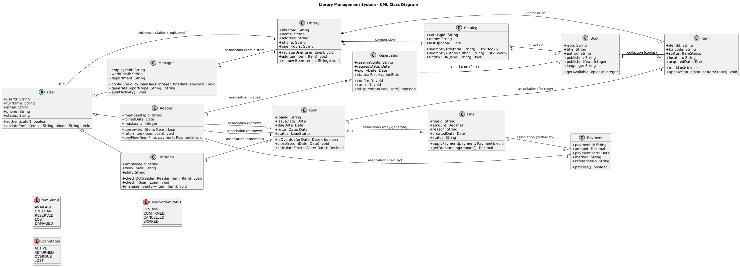
ChatGPT

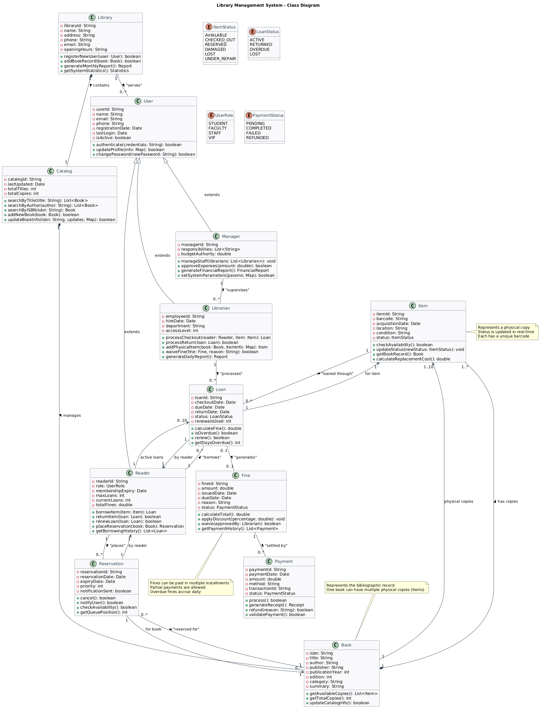
DeepSeek

Both diagrams satisfy Prompt 4 (inheritance, animations, properties + operations, relationship types, and multiplication) and render successfully (good). ChatGPT is more compact and readable, but it is less consistent in UML semantics (e.g., "union/collection" labels) and misses some obvious links (e.g., reader-reservation, good-reader). DeepSeek provides a more complete domain model with clear structure chains (library → catalog → book → item), rich constraints/notes, and strong coverage of transactions and payments. Overall, DeepSeek is a strong Prompt 4 solution due to its completeness and more consistent modeling.
6. Comparative Evaluation
Evaluate each combination (Prompt × Model × Diagram type) using the criteria below.
Type | Prompt | Model | Code Renders | No Syntax errors | Overall(1-5)
Use Case | 1 | ChatGPT | OK | No errors | 5
Use Case | 1 | DeepSeek | OK | no errors | 4
Use Case | 2 | ChatGPT | OK | No errors | 5
Use Case | 2 | DeepSeek | OK | Minor errors | 3
Use Case | 3 | ChatGPT | OK | No errors | 4
Use Case | 3 | DeepSeek | OK | No errors | 4
Use Case | 4 | ChatGPT | OK | No errors | 4
Use Case | 4 | DeepSeek | OK | No errors | 4
Class | 1 | ChatGPT | OK | No errors | 5
Class | 1 | DeepSeek | OK | No errors | 5
Class | 2 | ChatGPT | OK | No errors | 4
Class | 2 | DeepSeek | OK | No errors | 4
Class | 3 | ChatGPT | OK | No errors | 4
Class | 3 | DeepSeek | OK | No errors | 5
Class | 4 | ChatGPT | OK | No errors | 4
Class | 4 | DeepSeek | OK | No errors | 5

7. Conclusions
• Best prompt (Use Case): ChatGPT Prompt1
• Best prompt (Class Diagram): DeepSeek Prompt 3
DeepSeek was superior because it provided a more accurate and rich classical structure for creating Use Case and Class Diagrams. In addition, DeepSeek demonstrated the correct Item / Book interactions with good use of strong relationships (composition, aggregation), which is very important for UML. ChatGPT provided simple, clear and standards-compliant procedures, but DeepSeek remained a step ahead with its extensive processing speed and detail. Although DeepSeek did not meet the Prompt 1 criteria, it was very good as a realistic model.

